Battery Cycle Performance

As part of ongoing research to examine performance degradation caused by cycling, Cadex tested a large volume of portable batteries for wireless communication devices. The population consists of nickel-cadmium, nickel-metal-hydride and lithium-ion. The batteries were prepared by applying an initial charge, followed by a regime of full discharge/charge cycles. The internal resistance was measured with OhmTest™ and the self-discharge was obtained from time to time by reading the capacity loss incurred during a 48-hour rest period. The tests were carried out on the Cadex 7000 Series battery analyzers.
Lithium-ion battery cycle
Figure 1 examines the capacity and internal resistance of lithium-ion. We observe a gentle and predictable capacity drop over 1,000 cycles while the internal resistance increases only slightly. Because of low readings, we omit self-discharge. Lithium-ion offers the highest specific energy among the above-mentioned chemistries, contains little or no toxic metals, but needs protection circuits to ensure safe operation. Li-ion is also more expensive to manufacture than the nickel-based equivalent.
Batteries tested in a laboratory environment tend to give better results than when used in the field; elements of stress in everyday use do not transfer well into the laboratory. Aging plays a minimal role in a lab because the batteries are cycled over a period of a few months rather than the expected service life of a few years. The temperature is often moderate and the batteries are charged with proper charge equipment, an advantage that the field cannot always claim.

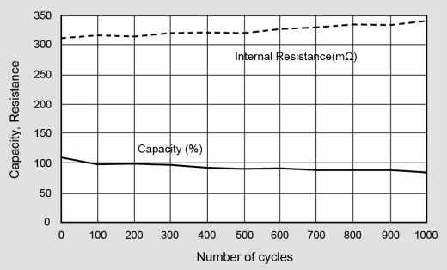
Figure 1: Performance of lithium-ion (3.6V, 500mA)
Lithium-ion offers good capacity and steady internal resistance over 1,000 cycles. Self-discharge was omitted because of low readings.
The load signature of the discharge plays an important role when testing batteries, and our laboratory batteries were discharged with an even DC load. Cellular phones and other digital devices draw pulsed loads that stress the battery more than with DC. One could argue, however, that the lab tests apply a full discharge whereas the field user discharges the battery to about 80 percent. The degradation of a battery receiving a 100 percent discharge with a DC load may not be the same as an 80 percent discharge on a pulsed load, and we keep this possible discrepancy in mind when studying the results.
The tests were done with batteries from an earlier generation. Newer models show improved results, and this is especially apparent with NiMH. The internal resistance of the modern NiMH is similar to NiCd, so is the cycle life. The Li-ion battery tested was Li-cobalt for cellular phones. We excluded lead acid from the test because this battery is seldom used for portable applications. Lead acid is heavy and does not cycle well, especially on full discharges.
The outcome of battery tests depends very much on the application for which the battery is designed, and we distinguish between consumer and industrial use. With the advent of the electric powertrain, a new category of batteries is emerging. Built for safety and longevity, these batteries have a specific energy that is typically only one-half that of consumer batteries.

